**Sukkur IBA University**

**Software Requirement Specification (SRS)**

For

**Brain Unpacked - 3D**

Version 1.4

Muhammad Hasnain, Sajjad Ali, Mujeeb Ahmed

Supervisor: Dr. Ahsanullah Abro

|  |  |
| --- | --- |
| ***Project Code*** | 19F-09 |
| ***Supervisor*** | Dr. Ahsanullah Abro |
| ***Co-Supervisor*** | N/A |
| ***Project Manager*** | Muhammad Hasnain |
| ***Project Team*** | Muhammad Hasnain  Sajjad Ali  Mujeeb Ahmed |
| ***Submission Date*** | February 2, 2023 |

***Document History***

*[Revision history will be maintained to keep a track of changes done by anyone in the document.]*

|  |  |  |  |
| --- | --- | --- | --- |
| Version | Name of Person | Date | Description of Changes |
| 1.1 | Muhammad Hasnain | 14-02-2023 | Changes in Headings, format and abbreviations. |
| 1.2 | Muhammad Hasnain | 15-02-2023 | Changes in Functional Requirements |
| 1.3 | Muhammad Hasnain | 16-02-2023 | Added Use Cases Diagram |
| 1.4 | Sajjad Ali | 16-02-2023 | Changes in Conclusion |
| 1.5 | Sajjad Ali | 17-02-2023 | Changes in Objectives |

***Distribution List***

*[Following table will contain list of people whom the document will be distributed after every sign-off****]***

|  |  |
| --- | --- |
| Name | Role |
| Dr. Ahsanullah Abro | Supervisor |
| Muhammad Hasnain | Project Manager |
| Sajjad Ali | Group Member |
| Mujeeb Ahmed | Group Member |

***Document Sign-off***

*[Following table will contain sign-off details of document. Once the document is prepared and revised, this should be signed-off by the sign-off authority.*

*Any subsequent changes in the document after the first sign-off should again get a formal sign-off by the authorities.]*

|  |  |  |  |
| --- | --- | --- | --- |
| Version | Sign-Off Authority | Project Role | Sign-Off Date |
|  |  |  |  |
|  |  |  |  |
|  |  |  |  |
|  |  |  |  |
|  |  |  |  |

Table of Contents

1. Introduction 6

1.1. Purpose of Document 6

1.2. Intended Audience 6

1.3. Document Convention 6

1.4. Project Scope 6

1.5. Not in Scope 6

2. Overall System Description 7

2.1. Project Background 7

2.2. Project Objectives 7

2.3. Stakeholders 7

2.4. Operating Environment 8

2.5. System Constraints 8

2.6. Assumptions and Dependency 9

3. External Interface Requirements 9

3.1. Hardware Interface 9

3.2. Software Interface 10

3.3. Communication Interface 10

4. Functional Requirements 11

4.1. Functional Hierarchy 11

4.2. Use Cases 12

4.2.1. View Brain Model 12

4.2.2. View Brain Information 13

4.2.3. Take Quiz/Assessment 13

5. Non-Functional Requirements 14

5.1. Performance Requirements 14

5.2. Reliability Requirements 14

5.3. Security Requirements 14

5.4. User Documentation 14

6. Conclusion 14

# Introduction

## Purpose of Document

The purpose of this document is to specify the requirements for the Three Dimensions (3D) mobile application for human brain. This Application (app) will be a tutorial tool for learning human brain anatomically, physiologically, morphologically and taxonomically.

## Intended Audience

The intended audience for the 3D android application for the human brain are students, educators, and anyone who is interested in learning about the human brain in an interactive and immersive way. The app offers a unique way to understand the human brain through taxonomical, anatomical, physiological, and morphological perspectives by utilizing 3D models. The app is user-friendly and easy to navigate, making it accessible to a wide range of audiences, including students of all ages and individuals who are new to the subject. The app is designed to provide a fun and engaging learning experience for its users and to help them gain a deeper understanding of the complex structure and functions of the human brain.

## Document Convention

The heading in this document is Calibri Light and font size is 13 whereas font of content is “Times New Roman” and font size is 12.

## Project Scope

The scope of this application will include the following features:

* Interactive 3D visualization of the human brain
* Detailed information on different parts of the brain
* Information on the functions of each part of the brain
* Quizzes and assessments to test the user's understanding

## Not in Scope

The following items are not in scope for the 3D android application for the human brain:

* Integration with other systems or applications.
* Any hardware requirements beyond a device with an Android operating system and access to the Google Play Store.
* User data storage and management.
* User authentication or login functionality.
* User accounts or profiles.
* Advertising or in-app purchases.
* User feedback or support mechanisms.
* Accessibility features for individuals with disabilities.
* Technical support or maintenance of the application.
* Compliance with legal or regulatory requirements beyond those required for distributing an Android app via the Google Play Store.

These items may be addressed in separate documents or in future iterations of the application development process, but they are outside the scope of this initial SRS document.

# Overall System Description

## Project Background

The 3D android application for the human brain is a tutorial app that provides a unique and interactive way of learning about the human brain. The app will utilize 3D models to give users a visual and immersive experience as they learn about the different parts of the human brain and how they work. The app is intended to be used by students, educators, and anyone interested in learning about the human brain in a fun and engaging way. The development of this application aims to address the need for a more interactive and accessible way to learn about the human brain. Traditional learning methods, such as textbooks and lectures, can be dry and difficult to understand. With the use of 3D models and an intuitive user interface, the app will provide a more engaging and effective way to learn about the human brain. This project will utilize the Unity 3D platform to create the 3D models and develop the user interface. The application will be designed to run on Android devices and will be available for download from the Google Play Store. The development team will work to ensure that the app is user-friendly, accessible, and provides a seamless experience for its users. The project goal is to provide an innovative and effective way to learn about the human brain, making it accessible and enjoyable for a wide range of audiences.

## Project Objectives

The objectives of the 3D android application for the human brain are as follows:

* To design and develop an interactive User Interface to learn about the human brain using 3D models.
* To utilize the Unity 3D platform to create high-quality 3D models and develop an intuitive user interface.
* To offer learning to users about the human brain and its different parts of the human brain and how they work.
* To provide an engaging learning user experience to understand human brain for students, educators, and even anyone who is of his/hers interest.

The project objectives are designed to meet the needs of the target audience and provide an innovative and effective way to learn about the human brain. The development team is committed to ensuring that the app meets these objectives and provides a positive learning experience for its users.

## Stakeholders

The stakeholders for the 3D android application for the human brain include:

* Users: The users of the app will be students, educators, and anyone interested in learning about the human brain. They will benefit from the interactive and engaging way in which the app presents information about the human brain.
* Development Team: The development team will be responsible for designing, developing, and testing the app. They will benefit from the opportunity to develop their skills and gain experience in creating 3D applications.
* Project Manager: The project manager will be responsible for overseeing the development process, ensuring that the project objectives are met, and that the app is delivered on time and within budget.
* Investors: Investors will provide funding for the development of the app and will benefit from the financial return that the app is expected to generate.
* Educators: Educators will be able to use the app to support their teaching and engage students in learning about the human brain. They will benefit from the app's interactive and engaging approach to learning.
* Medical Professionals: Medical professionals will be able to use the app as a tool for educating their patients about the human brain. They will benefit from the app's scientifically accurate and engaging presentation of information.

The stakeholders in this project are diverse and have varying interests and needs. However, they all share a common goal: to develop and provide an innovative and effective learning tool for the human brain. The development team is committed to working with all stakeholders to ensure that the app meets their needs and provides a positive outcome for all.

## Operating Environment

The operating environment for the 3D Android application for human brain consists of the following requirements:

* Hardware Requirements: The application will run on any Android device with a minimum of 2GB of RAM, and a quad-core processor.
* Software Requirements: The application requires the latest version of Android operating system to be installed on the device.
* Network Requirements: The application requires an active internet connection to access online resources.

It is important to note that the operating environment described above may change as the development of the application progresses and new technologies become available. The operating environment may also be updated to take advantage of new features and capabilities in future versions of the Android operating system.

## System Constraints

The following are the system constraints for the 3D Android application for human brain:

* Memory Constraints: The application requires a minimum of 2GB of RAM to run smoothly, and may consume additional memory when loading large 3D models or displaying high-resolution images.
* Performance Constraints: The application requires a quad-core processor to run smoothly, and may experience performance issues on older devices with lower-end processors.
* Connectivity Constraints: The application requires an active internet connection to access online resources and download additional content as needed.
* User Constraints: The application must be easy to use and intuitive for users of all ages, with clear and concise instructions provided for complex features.

It is important to note that these constraints may change as the development of the application progresses and new technologies become available. The development team will continually evaluate and update the system constraints to ensure that the application meets the needs and expectations of its intended audience.

## Assumptions and Dependency

The following are the assumptions and dependencies for the 3D Android application for human brain:

* Assumptions: It is assumed that users have basic knowledge of human anatomy and the structure of the human brain. The application will not provide a comprehensive introduction to these concepts, but rather build on existing knowledge to provide a deeper understanding of the human brain.
* Dependencies: The development of the application is dependent on the availability of 3D models and educational resources, which will be sourced from reputable online sources. The application may also require the use of third-party libraries and software tools for the implementation of certain features, such as 3D rendering and animation.
* Technical Dependencies: The application requires the use of the Unity 3D game engine to build and deploy the application, as well as the Android SDK for deployment to the Android platform. The development team must ensure that all required tools and technologies are available and properly configured prior to the start of development.
* Resource Dependencies: The development of the application requires the availability of qualified software developers, designers, and project managers. The development team must ensure that all necessary personnel are available and properly trained to perform their roles effectively.

It is important to note that any changes to these assumptions and dependencies may impact the timeline and budget of the project, and must be carefully considered and managed by the development team.

# External Interface Requirements

## Hardware Interface

Hardware Interfaces section of the SRS document describes the physical and technical specifications of the hardware components that are required to support the 3D Android application for human brain. This section should include details about:

* Device requirements: The type of devices the application will run on, such as smartphones or tablets, with minimum operating system and screen resolution requirements.
* Storage requirements: The amount of storage space required to install the application and its associated files.
* Input devices: The types of input devices required to interact with the application, such as touch screens or buttons.
* Output devices: The types of output devices required to display the application, such as displays or speakers.
* Connectivity: Any connectivity requirements, such as Wi-Fi or cellular data, needed to access the application's content or features.

It is important to include this information to ensure the hardware can support the software and its intended functions.

## Software Interface

The Software Interfaces section of the SRS document describes the technical specifications and interactions between the 3D Android application for human brain and other software systems or applications. This section should include details about:

* Operating System compatibility: The operating system versions the application will support.
* APIs: Any APIs the application will use to access external data or services, including any security considerations.
* Third-party software: Any third-party software that the application will rely on, such as libraries or plugins.

Including these details helps to ensure the compatibility and seamless integration of the 3D Android application for human brain with other software systems

## Communication Interface

N/A

# Functional Requirements

## Functional Hierarchy

The functional hierarchy of the 3D android application for the human brain can be divided into the following modules:

* Brain Model View: This module is responsible for displaying the 3D model of the human brain and allowing the user to interact with it.
* Brain Information View: This module is responsible for displaying information related to the different parts of the human brain, including taxonomical, anatomical, physiological, and morphological perspectives.
* Quiz/Assessment: This module is responsible for allowing the user to take quizzes or assessments related to the human brain and track their progress.

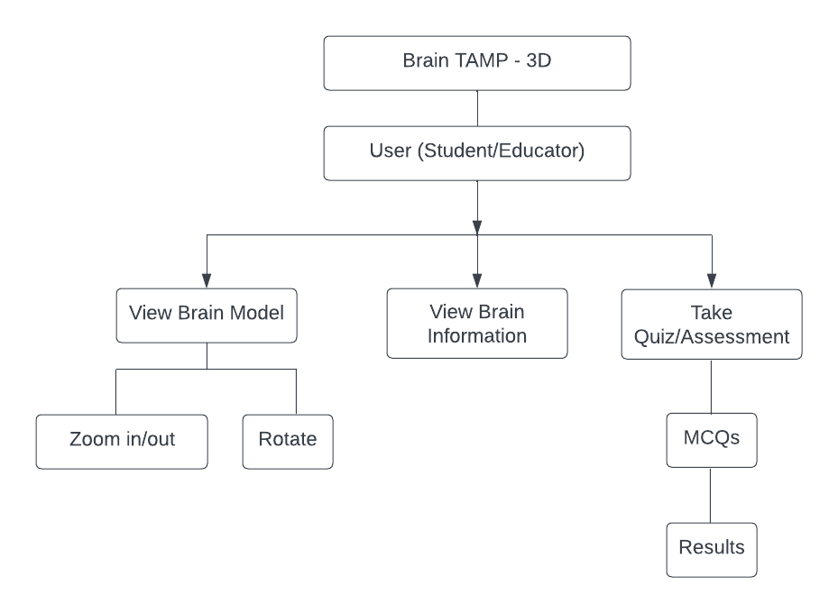

Figure Functional Hierarchy of Brain TAMP - 3D

## Use Cases

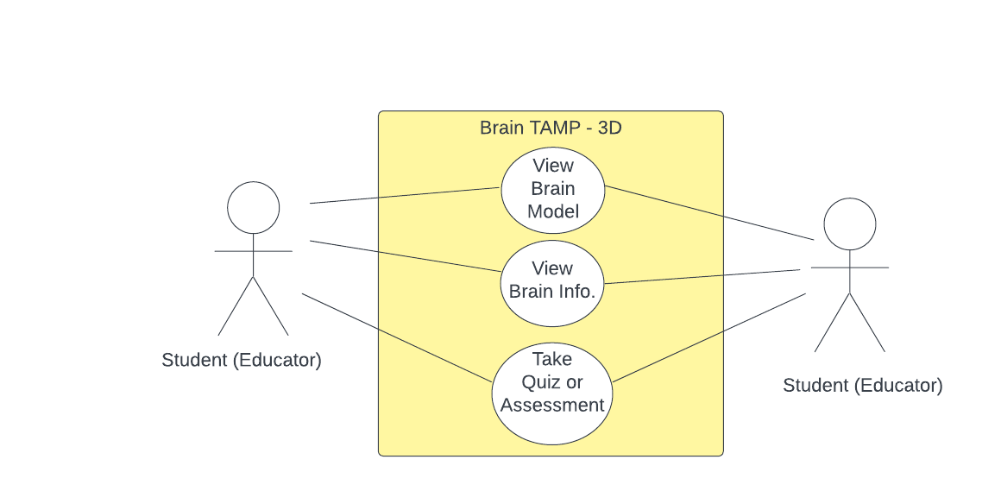

Figure Use Case Diagram

### View Brain Model

|  |  |
| --- | --- |
| **FSR01: View Brain Model** | |
| **Use case Id** | FSR01 |
| **Actors:** User (Student/ Educator) | |
| **Feature:** The user is able to view a 3D model of the human brain in the app. | |
| **Pre-condition:** | 1. The user has launched the 3D human brain tutorial app. 2. The app has loaded the 3D brain model. |
| **Trigger:** | The user selects the option to view the brain model. |
| **Scenario:**   * The user selects the "View Brain Model" option from the main menu. * The app displays the 3D brain model in the centre of the screen. * The user is able to rotate and zoom in/out on the model to view different angles and details of the brain. * The user can also click on various parts of the brain, such as the fore-brain, midbrain, and hind brain, to view them in more detail. | |
| **Post Conditions:** | |
| **Step#** | **Description** |
| **1.** | The user has successfully viewed the 3D brain model in the app. |
| **2.** | The user can choose to continue learning about the brain or return to the main menu. |
| **Use Case Cross referenced -** | |

### View Brain Information

|  |  |
| --- | --- |
| **FSR02: View Brain Information** | |
| **Use case Id** | FSR02 |
| **Actors:** User (Student/ Educator) | |
| **Feature:** The user wants to view information about a specific part of the human brain. | |
| **Pre-condition:** | The user has selected a specific part of the human brain from the 3D model. |
| **Trigger:** | The user clicks on the information button for the selected brain part. |
| **Scenario:**   * The application displays a new screen with the selected brain part in the center * The information about the selected brain part is displayed in a text box or in a separate section on the screen. * The information includes the name of the brain part, its location in the brain, its functions, and its structure. * The user can navigate through the information by scrolling up or down. * The user can return to the previous screen by clicking on a back button. | |
| **Post Conditions:** | |
| **Step#** | **Description** |
| **1.** | The user has successfully viewed the information about the selected brain part. |
| **Use Case Cross referenced -** | |

### Take Quiz/Assessment

|  |  |
| --- | --- |
| **FSR03: Take Quiz/Assessment** | |
| **Use case Id** | FSR03 |
| **Actors:** User (Student/ Educator) | |
| **Feature:** This use case allows the user to test their understanding of the human brain by taking a quiz or assessment. | |
| **Pre-condition:** | User has successfully navigated to the quiz/assessment section of the app. |
| **Scenario:**   * The user selects the option to take a quiz or assessment. * The app displays a set of multiple choice questions or tasks related to the human brain. * The user answers the questions or completes the tasks. * The app evaluates the user's answers and displays the results. * The user has the option to review their answers or retake the quiz/assessment. | |
| **Post Conditions:** | |
| **Step#** | **Description** |
| **1.** | The user has received a score that reflects their understanding of the human brain. |
| **Use Case Cross referenced -** | |

# Non-Functional Requirements

## Performance Requirements

The application should run smoothly on Android devices with minimum system requirements and not have any lag or delay in loading the 3D models and information.

## Reliability Requirements

The application should be reliable and have minimal downtime. The application should not crash or have any unexpected errors.

## Security Requirements

The application should be secure from any unauthorized access or data theft. The personal information of the users should be protected and not shared with any third parties.

## User Documentation

N/A

# Conclusion

In conclusion, our 3D Android application for learning the human brain from a taxonomical, anatomical, physiological, and morphological perspective is a unique and valuable tool for students, educators, and anyone who wants to explore the complexities of the human brain. With its intuitive interface, interactive 3D models, and informative content, the app provides a comprehensive and engaging learning experience that is both fun and informative. The software design and specifications have been carefully crafted to ensure that the app meets the needs and expectations of its users. We are confident that this app will be a valuable addition to the field of education and research, and we look forward to the positive impact it will have on its users.